TE (SEMVI) Academic Year: 2019-2020
LIST OF EXPERIMENTS
Course Outcomes:
Course Outcome | After successful completion of the course students should be able to
CO1 | Design basic two pass Assembler (B2-Understanding)
CO2 | Design basic two pass Macro Pre-processor and Loader (B2-Understanding)
CO3 | Acquire knowledge on various phases of Compiler. (Apply B3)
CO4 | Design various parsing techniques (B2-Understanding)

Sl.No | Experiment Title | CO Mapping
1. | Implement symbol table | CO1 and CO3
2. | Implement basic pass1 and pass2 of two pass assemblers | CO1
3 | Implement basic pass1 and pass2 of two pass Macro Processor | CO2
4 | Implement absolute Loader | CO2
5 | - Design Lexical Analyzer using High Level Language  - Design of Lexical Analyzer using Tool- LEX  - Case study on Natural Language Tool Kit ( Apply phases of Compiler) | CO3
6 | Design of top Down Parser- Recursive Decent Parser | CO4
7 | Design of Syntax Analysis- Validate arithmetic expression using YACC | CO4
8 | Code Generation Phase | CO3
9 | Design Text editor with basic features and additional three unique features | CO3

Experiment No 1
AIM:
To write a program for implementing Symbol Table
ALGORITHM
Step1: Start the program for performing insert, display, delete, search and modify option in symbol table
Step2: Define the structure of the Symbol Table
Step3: Enter the choice for performing the operations in the symbol Table
Step4: If the entered choice is 1, search the symbol table for the symbol to be inserted. If the symbol is
already present, it displays “Duplicate Symbol”. Else, insert the symbol and the corresponding address in
the symbol table.
Step5: If the entered choice is 2, the symbols present in the symbol table are displayed.
Step6: If the entered choice is 3, the symbol to be deleted is searched in the symbol table.
Step7: If it is not found in the symbol table it displays “Label Not found”. Else, the symbol is deleted.
Step8: If the entered choice is 5, the symbol to be modified is searched in the symbol table.

Sample Input and Output:

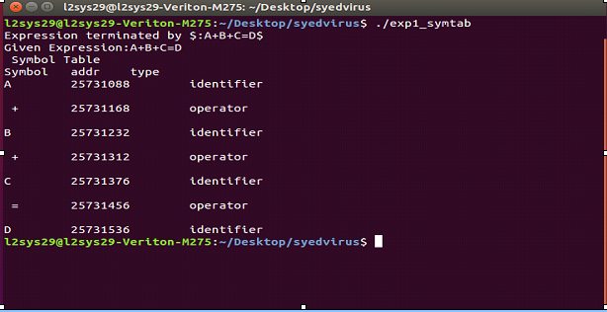
Postlab Questions:
1. Explain the role of Symbol table in the phases compiler with diagram

Experiment No 2

Aim: Write a program to implement Two Pass Assembler

Learning Objective: Translating mnemonic operation codes to their machine language equivalents. Assigning machine addresses to symbolic labels used by the programmer. Lastly to convert assembly language to binary.

Algorithm:
Pass 1:
1. Start
2.Intialize location counter to zero
3.Read opcode field of next instruction.
4.search opcode in pseudo opcode Table(POT)
5.If opcode is found in POT
5.1 If it is ‘DS’ or ‘DC’
Adjust location counter to proper alignment.
Assign length of data field to ‘L’
Go to step 9
5.2 If it is ‘EQU’
Evaluate operand field
Assign values to symbol in label field
Go to step 3
5.3 If it is ‘USING’ or ‘DROP’ Go to step 3
5.4 If it is ‘END’
Assign value to symbol in label field
Go to step 3
6. Search opcode in Machine Opcode Table.
7. Assign its length to ‘L’.
8. Process any literals and enter them into literal Table.
9.If symbol is there in the label field
Assign current value of Location Counter to symbol
10. Location Counter= Location Counter +L.
11.Go to step 3.
12. Stop.
Pass2:
1.Start
2.Intialize location counter to zero.
3. Read opcode field of next instruction.
4.Search opcode in pseudo opcode table.
5.If opcode is found in pseudo opcode Table
5.1 If it is ‘DS’ or ‘DC’
Adjust location counter to proper alignment.
If it is ‘DC’ opcode form constant and insert in assembled program
Assign length of data field to ‘L’
Go to step 6.4
5.2 If it is ‘EQU’ or ‘START’ ignore it. Go to step 3
5.3 If it is ‘USING’
Evaluate operand and enter base reg no. and value into base table
Go to step 3
5.4 If it is ‘DROP’
Indicate base reg no . available in base table . Go to step 3
5.5 If it is ‘END’
Generate literals for entries in Literal Table
Go to step 12
6 Search opcode in MOT
7. Get opcode byte and format code
8. Assign its length to ‘L’.
9. Check type of instruction.
10.If it is type ‘RR’ type
10.1 Evaluate both register expressions and insert into second byte.
10.2 Assemble instruction
10.3 Location Counter= Location Counter +L.
10.4.Go to step 3.
11. If it is ‘RX’ type
11.1 Evaluate register and index expressions and insert into second byte.
11.2 Calculate effective address of operand.
11.3 Determine appropriate displacement and base register
11.4 Put base and displacement into bytes 3 and 4
11.5 Location Counter= Location Counter +L.
11.6 Go to step 11.2
13 Stop.

Implementation Details

- Read Assembly language input file
- Display output of Pass1 as the output file with Op-code Table, Symbol Table
- Display output of pass2 as the Op-code Table, Symbol Table , Copy file
Test Cases:
1 Input symbol which is not defined
2 Input Opcode which is not entered in MOT
Conclusion:

Post Lab Questions:
- Define the basic functions of assembler.
- What is the need of SYMTAB (symbol table) in assembler?
- What is the need of MOT in assembler
- What is meant by one pass assembler?

Experiment No 3

Aim: Write a program to implement two pass Macro Processor

Learning Objective: To understand how the pre-processor replaces all the macros in the program by its real definition prior to the compilation process of the program.

Algorithm:
Pass1:
1. Set the MDTC (Macro Definition Table Counter) to 1.
2. Set MNTC (Macro Name Table counter) to 1.
3. Read next statement from source program.
4. If this source statement is pseudo-opcode MACRO (start of macro definition)
5. Read next statement from source program (macro name line)
6. Enter Macro name found in step 5 in name field of MNT ( macro name table)
7. Increment MNTC by 1.
8. Prepare ALA
9. Enter macro name into MDT at index MDTC
10.Increment MDTC by 1.
11. Read source statement from source program
12. Create and substitute index notation for arguments in the source statement if any.
13. Enter this line into MDT
14. Increment MDTC by 1.
15. Check if currently read source statement is pseudo-opcode MEND. If yes then goto step 3 else goto step 11.
16. Write source program statement as it is in the file
17.Check if pseudo-opcode END is encountered. If yes goto step 18 else goto step 19
18. Goto Pass2
19. Go to step 3
20. End of PASS1.
Pass2:
1. Read next statement from source program
2. Search in MNT for match with operation code
3. If macro name found then goto step 4 else goto step 11.
4. Retrieve MDT index from MNT and store it in MDTP.
5. Set up argument list array
6. Increment MDTP by one.
7. Retrieve line pointer by MDTP from MDT
8. Substitute index notation by actual parameter from ALA if any.
9. Check if currently retrieved line is pseuodo-opcode MEND, if yes goto step 1 else goto step 10
10. Write statement formed in step 8 to expanded source file and goto step 6
11. Write source statement directly into expanded source file
12. Check if pseudo-opcode END encountered, if yes goto step 13 else goto step 1
13. End of PASS II

Implementation Details
1.Read input file with Macros
2.Display output of Pass1 as the output file, MDT, MNT, and ALA tables.
3.Display output of pass2 as the expanded source file, MDT, MNT and ALA tables.
Test Cases :
- Call macro whose definition is not present
- Define macro without MEND

Conclusion:

Post Lab Questions:
- What is meant by macro processor?
- What are the features of macro processor?
- Explain advantages and disadvantages of Macro-assembler

Experiment No 4

Aim: Write a program to implement Absolute loader

Learning Objective: Describes the functions of loader that brings the object program into memory for execution.

Algorithm:
Begin
read Header record
verify program name and length
read first Text record
while record type is NQ ‘E’
do
begin
move object code to specified location in memory
read next object program record
end
jump to address specified in End record
end

Implementation Details
- Read input file with all three headers
- Display the output with memory map.
Conclusion:

Post Lab Questions:
- What is bootstrap Loader
- Write the need of two passes of Direct Linking Loader

Experiment No 5(a)

Aim: Write a program to implement Lexical analyzer

Learning Objective: Converting a sequence of characters into a sequence of tokens .
Theory:
THE ROLE OF LEXICAL ANALYZER

The lexical analyzer is the first phase of a compiler. Its main task is to read the input
characters and produce as output a sequence of tokens that the parser uses for syntax analysis. Upon receiving a “get next token” command from the parser, the lexical analyzer reads input characters until it can identify the next token.

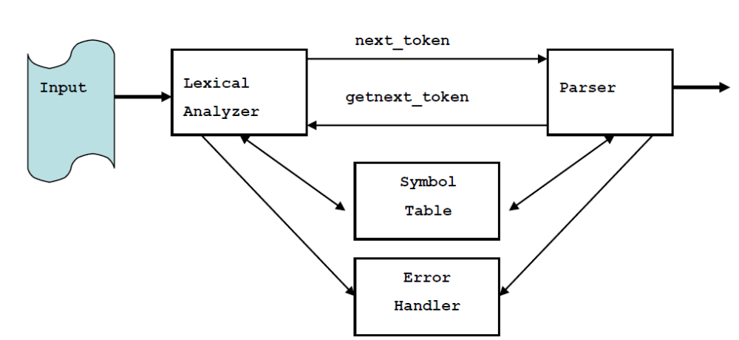
Figure 4.1 Interaction of Lexical Analyzer with Parser

Since the lexical analyzer is the part of the compiler that reads the source text, it may also perform certain secondary tasks at the user interface. One such task is stripping out from the source program comments and white spaces in the form of blank, tab, and new line characters. Another is correlating error messages from the compiler with the source program. Sometimes lexical analyzers are divided into a cascade of two phases first called “scanning” and the second “lexical analysis”. The scanner is responsible for doing simple tasks, while the lexical analyzer proper does the more complex operations.

Implementation Details
- Read the high level language as source program
- Convert source program in to categories of tokens such as Identifiers, Keywords, Constants, Literals and Operators.
Test cases:
- Input undefined token

Conclusion:

Post Lab Questions:
- Take any one statement of programming language and parse into different phases of compiler.
- What is symbol table?

Experiment No 5(b)
Aim : Study of Lexical analyzer tool -Flex/ Lex

Learning Objective: Recognise lexical pattern from given input file

Theory:
Lex is a program generator designed for lexical processing of character input streams. It accepts a high-level, problem-oriented specification for character string matching, and produces a program in a general-purpose language which recognizes regular expressions. The regular expressions are specified by the user in the source specifications given to Lex. The Lex written code recognizes these expressions in an input stream and partitions the input stream into strings matching the expressions. At the boundaries between strings program sections provided by the user are executed. The Lex source file associates the regular expressions and the program fragments. As each expression appears in the input to the program written by Lex, the corresponding fragment is executed. The user supplies the additional code beyond expression matching needed to complete his tasks, possibly including code written by other generators. The program that recognizes the expressions is generated in the general purpose programming language employed for the user's program fragments. Thus, a high level expression language is provided to write the string expressions to be matched while the user's freedom to write actions is unimpaired. This avoids forcing the user who wishes to use a string manipulation language for input analysis to write processing programs in the same and often inappropriate string handling language.
Lex is not a complete language, but rather a generator representing a new language feature which can be added to different programming languages, called ``host languages.'' Just as general purpose languages can produce code to run on different computer hardware, Lex can write code in different host languages. The host language is used for the output code generated by Lex and also for the program fragments added by the user. Compatible runtime libraries for the different host languages are also provided. This makes Lex adaptable to different environments and different users. Lex itself exists on UNIX, GCOS, and OS/370; but the code generated by Lex may be taken anywhere where appropriate compilers exist.
Lex turns the user's expressions and actions (called source in this pic) into the host general-purpose language; the generated program is named yylex. The yylex program will recognize expressions in a stream (called input in this pic) and perform the specified actions for each expression as it is detected.
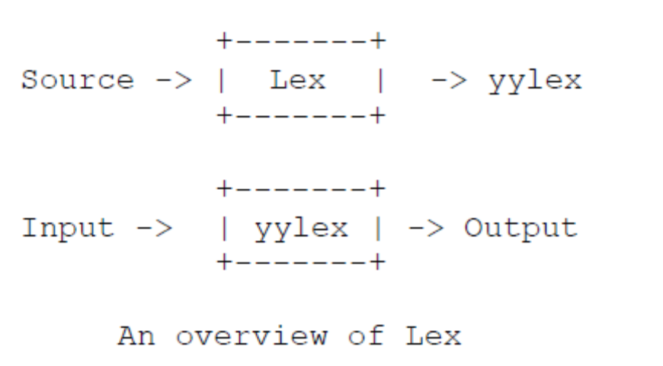

For a trivial example, consider a program to delete from the input all blanks or tabs at the
ends of lines.
%%
[ \t]+$ ;
is all that is required. The program contains a %% delimiter to mark the beginning of the rules, and one rule. This rule contains a regular expression which matches one or more instances of the characters blank or tab (written \t for visibility, in accordance with the C language convention) just prior to the end of a line. The brackets indicate the character class made of blank and tab; the + indicates ``one or more ...''; and the $ indicates ``end of line,'' as in QED. No action is specified, so the program generated by Lex (yylex) will ignore these characters. Everything else will be copied. To change any remaining string of blanks or tabs to a single blank, add another rule:
%%
[ \t]+$ ;
[ \t]+ printf(" ");
The finite automaton generated for this source will scan for both rules at once, observing at the termination of the string of blanks or tabs whether or not there is a newline character, and executing the desired rule action. The first rule matches all strings of blanks or tabs at the end of lines, and the second rule all remaining strings of blanks or tabs.
Lex can be used alone for simple transformations, or for analysis and statistics gathering on a lexical level. Lex can also be used with a parser generator to perform the lexical analysis phase.
The general format of Lex source is:
{definitions}
%%
{rules}
%%
{user subroutines}
where the definitions and the user subroutines are often omitted. The second %% is optional, but the first is required to mark the beginning of the rules. The absolute minimum Lex program is thus
%%
(no definitions, no rules) which translates into a program which copies the input to the output unchanged. In the outline of Lex programs shown above, the rules represent the user's control decisions; they are a table, in which the left column contains regular expressions and the right column contains actions, program fragments to be executed when the expressions are recognized. Thus an individual rule might appear integer printf("found keyword INT"); to look for the string integer in the input stream and print the message ``found keyword INT'' whenever it appears. In this example the host procedural language is C and the C library function printf is used to print the string. The end of the expression is indicated by the first blank or tab character. If the action is merely a single C expression, it can just be given on the right side of the line; if it is compound, or takes more than a line, it should be enclosed in braces.

Implementation Details:
1. Open file in text editor
2. Enter keywords, rules for identifier and constant, operators and relational operators. In
the following format
a) %{
Definition of constant /header files
%}
b) Regular Expressions
%%
Transition rules
%%
c) Auxiliary Procedure (main( ) function)
3. Save file with .l extension e.g. Mylex.l
4. Call lex tool on the terminal e.g. [root@localhost]# lex Mylex.l This lex tool will convert
“.l” file into “.c” language code file i.e. lex.yy.c
5. Compile the file lex.yy.c e.g. gcc lex.yy.c .After compiling the file lex.yy.c, this will
create the output file a.out
6. Run the file a.out e.g. ./a.out
7. Give input on the terminal to the a.out file upon processing output will be displayed
Test Cases:
- Input integer constant
- Input special symbols
Conclusion:

Example: Program for counting number of vowels and consonant

%{
#include <stdio.h>
int vowels = 0;
int consonants = 0;
%}
%%

[aeiouAEIOU] vowels++;
[a-zA-Z] consonants++;
[\n] ;
. ;
%%
int main()
{
printf ("This Lex program counts the number of vowels and ");
printf ("consonants in given text.");
printf ("\nEnter the text and terminate it with CTRL-d.\n");
yylex();
printf ("Vowels = %d, consonants = %d.\n", vowels, consonants);
return 0;
}
Output:
#lex alphalex.l
#gcc lex.yy.c
#./a.out
This Lex program counts the number of vowels and consonants in given text.
Enter the text and terminate it with CTRL-d.
Iceream
Vowels =4, consonants =3.

Experiment No 6
Aim : Design recursive descent parser
Theory :
A recursive descent parser is a kind of top-down parser built from a set of mutually-recursive procedures (or a non-recursive equivalent) where each such procedure usually implements one of the production rules of the grammar. Thus the structure of the resulting program closely mirrors that of the grammar it recognizes.
This parser attempts to verify that the syntax of the input stream is correct as it is read from left to right. A basic operation necessary for this involves reading characters from the input stream and matching then with terminals from the grammar that describes the syntax of the input. Our recursive descent parsers will look ahead one character and advance the input stream reading pointer when proper matches occur.
What a recursive descent parser actually does is to perform a depth-first search of the derivation tree for the string being parsed. This provides the 'descent' portion of the name. The 'recursive' portion comes from the parser's form, a collection of recursive procedures.
As our first example, consider the simple grammar
E ® x+T
T ® (E)
T ® x
and the derivation tree in figure 2 for the expression x+(x+x)
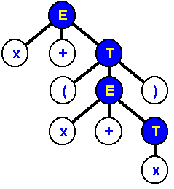
Derivation Tree for x+(x+x)
A recursive descent parser traverses the tree by first calling a procedure to recognize an E. This procedure reads an 'x' and a '+' and then calls a procedure to recognize a T. This would look like the following routine.
Procedure E()
Begin
If (input_symbol=’x’) then
next();
If (input_symbol=’+’) then
Next();
T();
Else
Errorhandler();
END

Procedure for E
Note that the 'next' looks ahead and always provides the next character that will be read from the input stream. This feature is essential if we wish our parsers to be able to predict what is due to arrive as input.
Note that 'errorhandler' is a procedure that notifies the user that a syntax error has been made and then possibly terminates execution.
In order to recognize a T, the parser must figure out which of the productions to execute. This is not difficult and is done in the procedure that appears below.
Procedure T()
Begin
Begin
If (input_symbol=’(‘) then
next();
E();
If (input_symbol=’)’) then
next();
end
else If (input_symbol=’x’) then
next();
else
Errorhandler();
END

Procedure for T
In the above routine, the parser determines whether T had the form (E) or x. If not then the error routine was called, otherwise the appropriate terminals and nonterminals were recognized.
Algorithm:
1. Make grammar suitable for parsing i.e. remove left recursion(if required).
2. Write a function for each production with error handler.
3. Given input is said to be valid if input is scanned completely and no error function is called.

Conclusion:

- What is left Recursion ? Write the rules for removing left recursion.
- What is left factoring ? Write rules for eliminating left factoring.

Experiment No 7

Aim : Study of Parser generator tool – Yacc

Leraning Objective:

Theory:
Parser for a grammar is a program which takes in the language string as its input and produces either a corresponding parse tree or a error. Syntax of a Language The rules which tells whether a string is a valid program or not are called the syntax Semantic s of Language The rules which give meaning to programs are called the semantic of a language Tokens When a string representing a program is broken into sequence of substrings, such that each substring represents a constant, identifier, operator, keyword etc of the language, these substrings are called the tokens of the language.
Lexical Analysis
The function of lexical Analyzer is to read the input stream representing the source program , one character at a time and translate into valid tokens.
Implementation Details
1: Create a lex file
The general format for lex file consists of three sections:
- Definitions
- Rules
- User subroutine Section
Definitions consists of any external ‘C’ definitions used in the lex actions or subroutines. The other types of definitions are definitions are lex definitions which are essentially the lex substitution strings, lex start states and lex table size declarations. The rules is the basic part which specifies the regular expressions and their corresponding actions. The user Subroutines are the functions that are used in the Lex actions.
2 : Yacc is the Utility which generates the function ‘yyparse’ which is indeed the Parser. Yacc describes a context free, LALR(1) grammer and supports both bottom up and top-down parsing. The general format for the yacc file is very similar to that of the lex file.
- Declarations
- Grammar Rules
- Subroutines
In declarations apart from the legal ‘C’ declarations here are few Yacc specific declarations which begins with a % sign.
- % union It defines the Stack type for the Parser.
It is union of various datas/structures/objects.
- % token These are the terminals returned by the yylex function to the yacc. A token cal also have type associated with it for good type checking and syntax directed translation. A type of a token can be specified as % token <stack member> tokenName.
- %type The type of non-terminal symbol in the grammar rule can be specified with this. The format is %type <stack member> non termainal.
- % noassoc Specifies that there is no associativity of a terminal symbol.
- % left Specifies the left associativity of atermainal symbol.
- % rightSpecifies the right associativity of a termainal symbol.
- % start specifies the L.H.S. non-terminal symbol of a production rule which specifies starting point of grammar rules.
- % prac changes the precedence level associated with a particular rule to that of the following token name or literal.
The Grammar rules are specified as follows:
Context free grammar production-
p-> AbC
Yacc Rule-
P: A b C { /* ‘C’ actions*/}
The general style of coding the rules is to have all Terminals in lower –case and all non-terminals in upper –case.
To facilitate a proper syntax directed translation the Yacc has something calls pseudo-variables which forms a bridge between the values of terminals/non-terminals and the actions. These pseudo variables are $$, $1, $2, $3,………….The $$ is the L.H.S value of the rule whereas $1 is the first R. H. S value of the rule, so is the $2 etc. The default type for pseudo variables is integer unless they are specified by % type.
%token <type> etc.
Perform the following steps, in order, to create the desk calculator example program:
- Process the yacc grammar file using the -d optional flag (which tells the yacc command to create a file that defines the tokens used in addition to the C language source code):
yacc -d calc.yacc
- Use the li command to verify that the following files were created:
y.tab.c | The C language source file that the yacc command created for the parser.
y.tab.h | A header file containing define statements for the tokens used by the parser.
- Process the lex specification file:
lex calc.lex
- Use the li command to verify that the following file was created:
lex.yy.c | The C language source file that the lex command created for the lexical analyzer.
- Compile and link the two C language source files:
cc y.tab.c lex.yy.c
- Use the li command to verify that the following files were created:
y.tab.o | The object file for the y.tab.c source file
lex.yy.o | The object file for the lex.yy.c source file
a.out | The executable program file
- To then run the program directly from the a.out file, enter:
- $ a.out

Conclusion:

Experiment No 8
Aim : Generate a target code for the optimized code.
Algorithm:
The final phase in compiler model is the code generator. It takes as input an intermediate representation of the source program and produces as output an equivalent target program.
The code generation algorithm takes as input a sequence of three address statements constituting a basic block. For each three address statement of the form x=y op z we perform following function:
1. Invoke a function getreg to determine the location L where the result of computation y op z should be stored. ( L cab be a register or memory location .
2. Consult the address descriptor for y to determine y, the current locations of y. Prefer the register for y if the value of y is currently both in memory and register. If value of y is not already in L , generate the instruction MOV y, L to place a copy of y in L.
3. Generate instruction po z, L where z is a current location of z. Again address descriptor of x to indicate that x is in location L. if L is a register, update its descriptor to indicate that it contains the value of x, and remove x from all other register descriptor.
4. If the current values of y and z have no next uses , are not live on exit from the block , and are in registers alter the register descriptor to indicate that , after execution of x=y op z, those register no longer will contain y and z, resply.
The function getreg:
The function getreg returns the location L to hold the values of x for the assignment x= y op z.
1.If the name y is in a reg that holds the value of no other names, and y is not live and has no next use after execution of x= y op z ,then return the register of y for L. Update the address descriptor of y to indicate that y is no longer in L.
2. Failing (1), return an empty register for L if there one.
3. Failing (2) , if X has a next use in the block, or op is an operator , such as indexing, that requires a register find an occupied register R. Store the values of R into a memory location ( MOV R ,M) if it is not already in the proper memory location M, update the address descriptor for M , and return R. if R holds the value of several variables, a MOV instruction must be generated for each variable that needs to be stored. A suitable register might be one whose data is referenced furthest in the future, or one whose value is also in memory. We leave the exact choice unspecified, since there is no one proven best way to make the selection.
4. If x is not used in the block , or no suitable occupied register can found, select the memory location of x as L.
Conclusion:

Postlab:
- What are important design issues of code generators? Explain each with example
- What are basic blocks? State their properties

